**Practical 7**

**AIM: -** Implementation and analysis of Linear regression through graphical methods

**Theory: -** Linear regression analysis is used to predict the value of a variable based on the value of another variable. The variable you want to predict is called the dependent variable. The variable you are using to predict the other variable's value is called the independent variable.

**R Commands:**

# setwd(“D:/53 FYMCA/prac7”)

#getwd()

[1] "D:/53 FYMCA/prac7"

# my_data <-mtcars

# names(my_data)



# dim(my_data)

------------- RANDOMIZE----------------

# my_data <- my_data[sample(nrow(my_data), ), ]

# head(my_data)

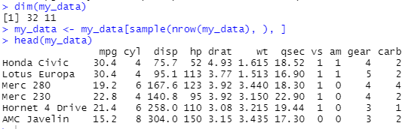

# TrainData <- my_data[1:20,]

# TestData <- my_data[21:32,]

-----------Linear Model--------------

# fit = lm(mpg ~ hp, data=mtcars)

# summary(fit)

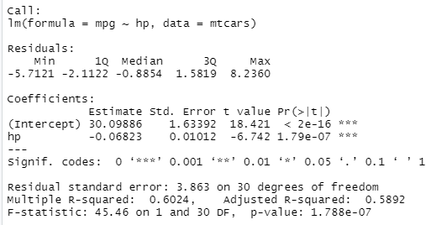

# preds <- predict(fit, newdata = TestData)

# df1 <-data.frame(preds,TestData$mpg)

# head(df1)

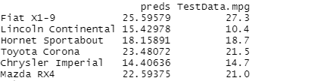

#Correlation :- cor(preds,TestData$mpg)



# plot(mtcars$hp, mtcars$mpg)

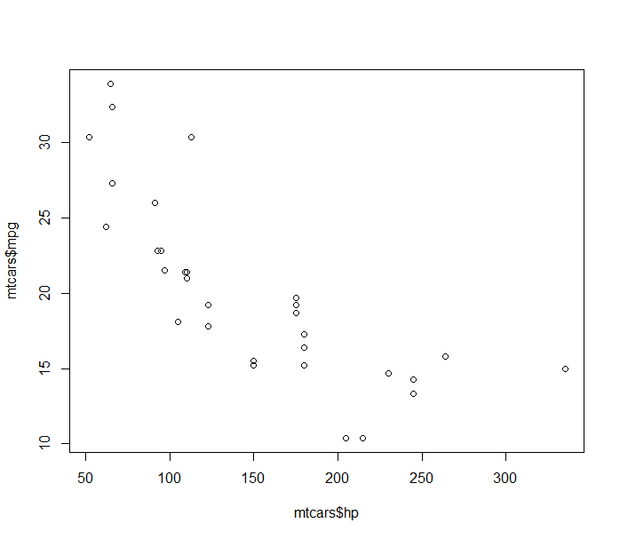

# ggplot(fit, aes(hp, mpg)) + geom_point() +

stat_smooth(method = lm, se = FALSE) +

geom_segment(aes(xend = hp, yend = .fitted), color = "red", size = 0.3)

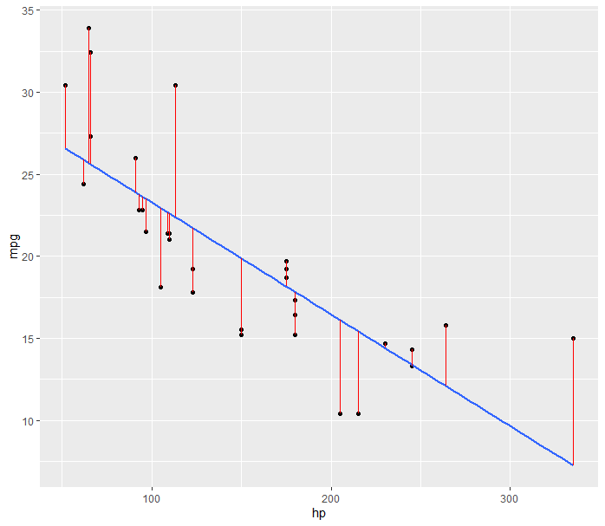

----------Better MODEL------------------

# lmmodel1 <- lm(mpg ~ hp+cyl+gear+wt, data =TrainData)

# summary(lmmodel1)

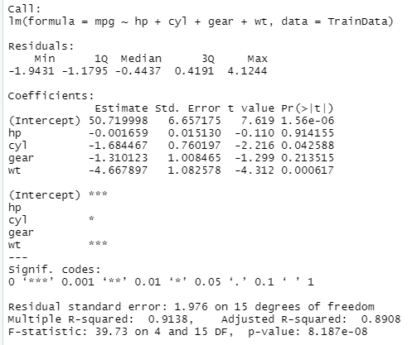

# preds_new <- predict(lmmodel1, newdata = TestData)

# df2 <-data.frame(preds_new,TestData$mpg)

# head(df2)

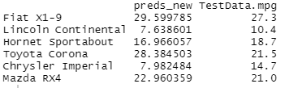

-------------Corelation---------

# cor(preds_new,TestData$mpg)



# ggplot(fit, aes(mtcars$hp+mtcars$cyl+mtcars$gear+mtcars$wt, mpg)) + geom_point() +

# stat_smooth(method = lm, se = FALSE) +

# geom_segment(aes(xend = hp, yend = .fitted), color = "red", size = 0.3)

